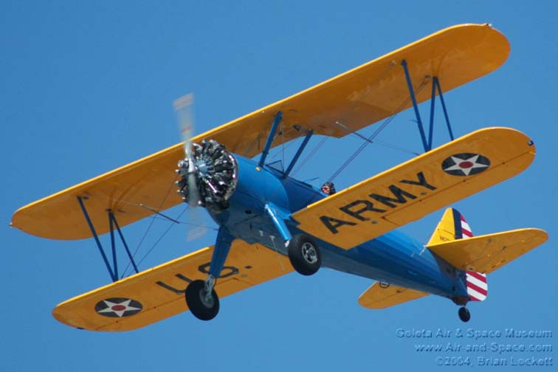
Model Aero Fly-In
Weekend Fun Fly
19th – 20th October 2019

Come and check out the sport of Aeromodelling
In the South Burnett and meet our Members

At the KAMS flying field – 844 Booie Crawford Road, Booie
Camping
available
Saturday Night
(by donation)
Chemical toilets,
tank water
& BBQ available.
Strictly No Dogs
No Camp Fires
No Turbines (Due to Fire Restrictions)

- General flying Saturday & Sunday
- Saturday Night Flying
- Breakfast Sunday morning
- Welcome Morning Tea and Fellowship - 10am Sunday
- Coffee, Tea, Sausage Sizzle & Cold Drinks all day Sunday
- General Public Most Welcome to visit and ‘Have a Go’

Bring along your excess bits and pieces to Buy Swap and Sell

