- As a Club, we and our visitors are very fortunate to have access to the exceptional flying site with the grace of the property owners, ‘The McLennan Family’. We need to respect their ownership and wishes at all times. We welcome interested members of the public, prospective aero modellers and visiting pilots affiliated with the Model Aeronautical Association of Australia.
- Visitors:
- The Club regular flying time is Sunday morning – weather permitting
- It is recommend that Visitors contact one of the executive members prior to going to site to confirm flying times.
- Flying visitors are not to use the facilities without a KAMS member on site.
- Site Rules:
- The steel farm gate at the entrance to the property must be chained closed at all times.
- The livestock on the property have right of way at all times and are not to be chased with vehicles or aircraft.
- All cars must follow the defined tracks and park in the car park area.
- Dogs are NOT permitted on site.
- The property is a no smoking site.
- All rubbish is to be removed from the site on departure.
- All Visiting Flyers must introduce themselves to the most senior KAMS Member on site, produce their current MAAA affiliation licence and sign in the Visitors Register in the cupboard in the KAMS Hilton Clubhouse.
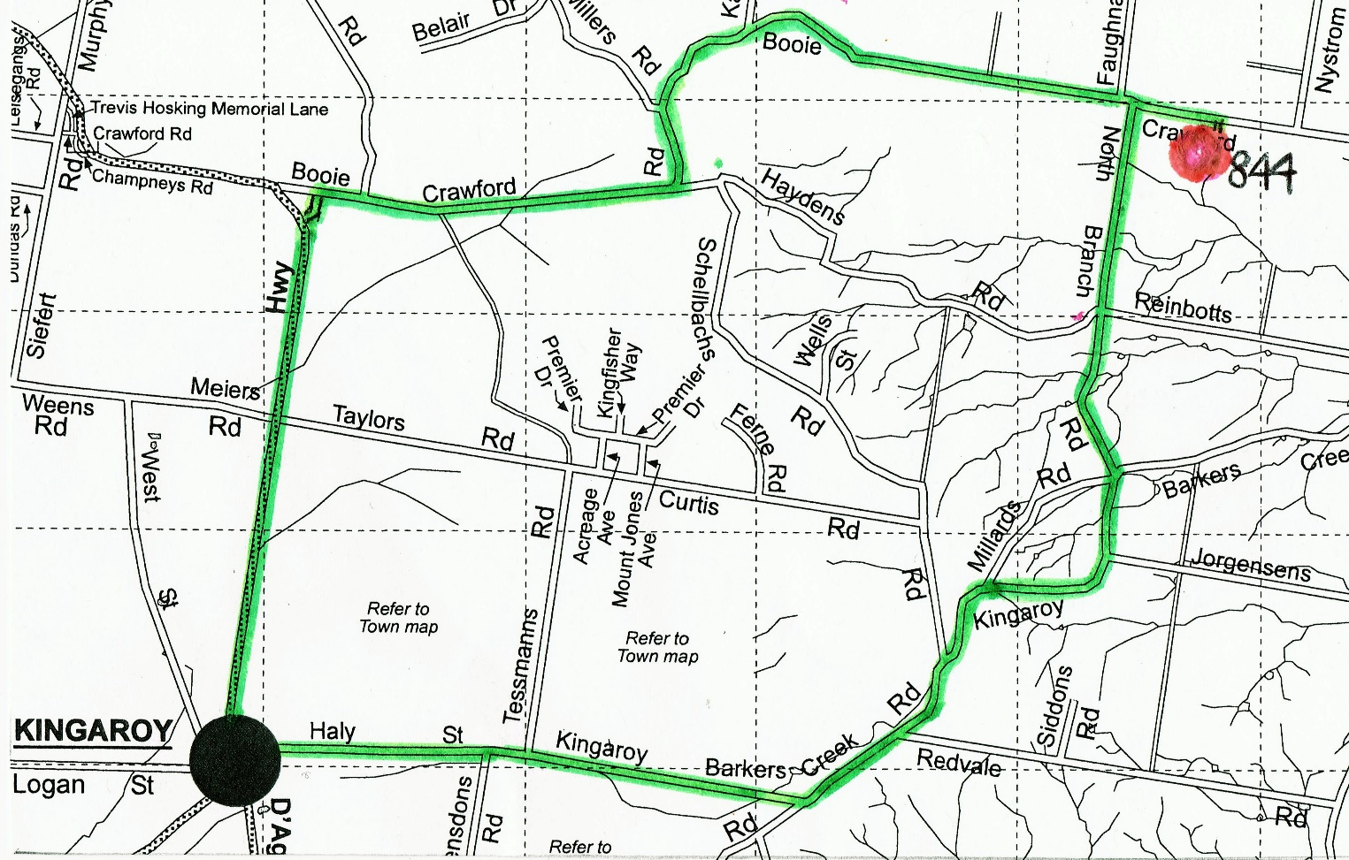
- Site Location: 844 Booie - Crawford Road, Booie.

